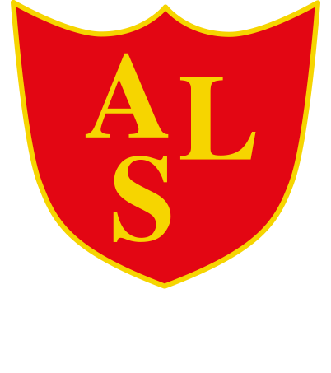
Annie Lennard Primary School

Uniform Policy

Update June 2025

School Uniform Policy
Introduction
It is our school policy that all children wear school uniform when attending school, or when participating in a school-organised event outside normal school hours. We provide a complete list of the items needed for school uniform on our school website.

Aims and Objectives
Our policy on school uniform is based on the notion that school uniform:
- promotes a sense of pride in the school;
- engenders a sense of community and belonging towards the school;
- is practical and smart;
- identifies the children with the school;
- prevents children from coming to school in fashion clothes that could be
- distracting in class;
- makes children feel equal to their peers in terms of appearance;
- is regarded as suitable wear for school and good value for money by
- parents;
- is designed with health and safety in mind.

Jewellery and Religious Garments
On health and safety grounds we do not allow children to wear jewellery in our school. The exceptions to this rule are earring studs in pierced ears, and small objects of religious significance. We ask the children to remove these objects during PE and games. We prefer that pupils have their ears pierced during the summer holidays so that they do not miss PE lessons.

Religious garments can be worn; however, bands need to be covered during P.E

Extreme Hair colour
The school does not permit children to have ‘extreme’ hair colour that could serve as a distraction to other children.

Footwear
Children should wear shoes, smart black trainers or boots to school. We believe that it is dangerous for children to wear shoes that have platform soles or high heels, so we do not allow children to wear such shoes in our school.

The role of parents
We ask all parents who send their children to our school to support the school uniform policy. We believe that parents have a duty to send their children to school correctly dressed and ready for their daily schoolwork. One of the responsibilities of parents is to ensure that their child has the correct uniform, and that it is clean and in good repair.

If any parent would like the school to modify the uniform policy, they should make representation, in the first instance, to the headteacher. The school welcomes children from all backgrounds and faith communities. If there are serious reasons, for example on religious grounds, why parents want their child to wear clothes that differ from the school uniform, the school will look sympathetically at such requests.

The role of the Governors
- The Governing Board supports the headteacher in implementing the school uniform policy. It considers all representations from parents regarding the uniform policy and liaises with the headteacher to ensure that the policy is implemented fairly and with sensitivity.
- It is the governors’ responsibility to ensure that the school uniform meets all regulations concerning equal opportunities.
- Governors ensure that the school uniform policy helps children to dress sensibly, in clothing that is hardwearing, safe and practical.
Monitoring and review
The Governing Board monitors and reviews the school uniform policy through its
committee work by:
- seeking the views of parents, to ensure that they agree with and support the policy;
- considering, with the headteacher, any requests from parents for individual children to have special dispensation with regard to school uniform;
- requiring the headteacher to report to the governors on the way the school uniform policy is implemented

Appendix 1
School Uniform

From September 2025 we are proposing a more relaxed approach to our uniform policy. If children wish to wear joggers and hoodies on non-PE days this now permitted. We want our pupils to feel comfortable throughout the day

Shorts/ skirts – these need to be mid-thigh length to knee length

Uniform | PE
Grey/ black Trousers  Grey/ black skirt/ pinafore  Grey/ black tracksuit bottoms  Grey/ black shorts (knee length)  White shirt/ blouse  Red/ Yellow or White polo shirt  Red sweatshirt, cardigan, or hoody  Red and white gingham dresses  Black shoes, black smart trainers or black boots  White, grey, red black socks or tights  NO make-up, nail varnish, jewellery or fashion accessories | Red/ black shorts  Grey/ black tracksuit bottoms  Red/ Yellow or White t-shirt  Red Hoody

Items with the Annie Lennard Logo on can be purchased My Clothing, however plain jumpers, t-shirts etc are also acceptable
myclothing.com/annie-lennard-primary-school/11172.school

in store at CC Uniforms Ltd 82 Kings Square, West Bromwich, B70 7NW or online www.ccuniforms.co.uk/product-category/school-uniform/annie-lennard-primary-school/
All clothing should be clearly marked with the child's name.

Swimming (Y3, 4 and 5) Towel / Trunks (not Bermuda’s) / Costume (not Bikinis)

Earrings should be studs only and no other jewellery should be worn for school. No earrings to be worn on P.E. days. If you are considering having your child’s ears pierced it would be much appreciated if this were done at the beginning of the summer holidays.

